FFA Pledge:’’ To practice brotherhood, honor agricultural opportunities and responsibilities and developed those qualities of leadership which an FFA member should possess.’’

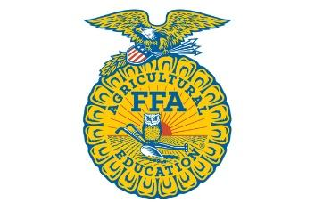
Opening
Opening Ceremonies
FFA Pledge

Treasurer's Report

New Business

Jackson County Youth Fair Set Up- Saturday, October 2nd @ 2:00pm
Jackson County Parade- Saturday, October 2nd @ 10:30 Need to vote
September 20th- Major Heifer & Swine tag $20 due to Ag Teachers
Junior members are due- $10
LDE teams - Sign up sheets are with Ms. Wells and Mrs. Linke, make sure to sign up.
Seitz fundraiser- Everyone needs to sell
Chapter shirt design
Trunk of Treat

Announcements:
VICTORIA LIVESTOCK SHOW Tag-In Dates:
September 28th - 5:00-8:00PM - Pole Barn - Market & Carcass Steers
October 9th - 8:00 AM-Noon - Briggs Ranch - Commercial Heifers
October 16th - 8-9AM - Pole Barn - Market Lamb/Goat & Carcass Lamb
October 25th - 4-6PM - Pole Barn - Market Lamb/Goat & Carcass Lamb

Closing ceremonies

