FFA Pledge:’’ To practice brotherhood, honor agricultural opportunities and responsibilities and developed those qualities of leadership which an FFA member should possess.’’
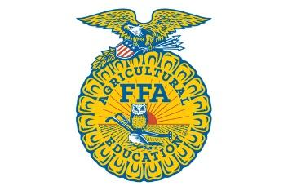
Opening
Opening Ceremonies
FFA Pledge

Treasurer's Report

Old Business
Jackson County Youth Results- Please stand up and announce how you did
Jackson County Parade-

New Business
Junior Member Dues- $10
LDE Teams- Sign up sheets are with Ms. Wells and Mrs. Linke, make sure to sign up.
Seitz fundraiser- Seitz is due tomorrow, October 13th.
Chapter Shirt- They will be sent out next week
Trunk or Treat- October 29th 3:30 - 5:30 pm Please bring a bag of candy
Booster Club- Let your parents know to become an active member
Pink Out- Please make sure you help with our take down process
November Meeting- Seitz pick-up and sponsor a family
Spring Major Shows- Please see Mrs. Linke or Ms. Wells for entry forms. Entry forms are due no later than November 9th at 5:30 pm.
VLS Entries- Entries are now available ONLINE

Announcements:
October 16th - 8-9AM - Pole Barn - VLS Market Lamb/Goat & Carcass Lamb Tagging
October 25th - 4-6PM - Pole Barn - VLS/Major Market Lamb/Goat & Carcass Lamb Tagging
November 1st - Major Heifers must be registered in the exhibitors name
November 13th - 8-9AM - Pole Barn - VLS Market Hog/Carcass/Breeding Gilt Tagging
December 4th - 8-9AM - Pole Barn - VLS Market Hog/Carcass/Breeding Gilt Tagging
December 6th - VLS Broiler Entry Deadline
December 31st - VLS Entry Deadline (excluding Broilers)

Closing ceremonies

